Medical Herbalism
An Advanced Understanding of Herbs

A holistic model of health & treatments will be elucidated. We will cover all the body systems and approximately 100 herbs by actions, pharmacology, and energetics. Advanced concepts and principles of the natural sciences will be introduced and applied. Botany, pharmacognosy, phytochemistry, pharmacology, herb-drug interactions, and human physiology will be presented with the principles addressed and integrated into the course at the appropriate times.

A holistic model of healing using the paradigms of deep ecology will be the basis of the paradigm in which herbal protocols will be formed. A systematic method of integrating Western Bio-Medical information in an inherently holistic context will allow the students to utilize the resources of what is called “Allopathic” medicine and “Holistic” or “Naturopathic” medicine.

A herbal materia medica will be developed and cross referenced by physiological action categories, body systems and tissues affinities, phamacognostic plant metabolites, energetics, and historical uses. Texts used:
Hoffmann, Medical Herbalism,
Romm, Botanical Medicine for Women’s Health
Hechtman, Clinical Naturopathic Medicine

Students may attend in person or through ZOOM.
Register soon to assure a position.
Thank you.
An application for CE from CONO is underway.

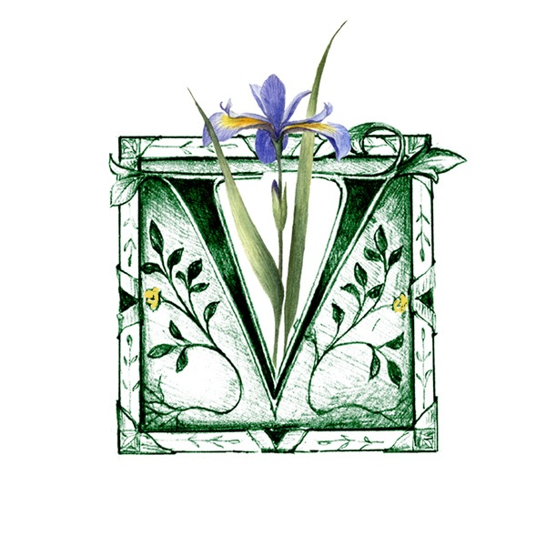

The basic structure of the classes will be
to take each body system and summarize its place in the whole. Next, the patterns that lead to disease conditions and the physiological processes involved will be examined in detail including some specific pathologies. Case studies (from intake to diagnosis to prescription) will be discussed using the “method” and herbal selection criteria to generate holistic protocols including patient specific herbal formulations. Proper forms of herbal products i.e. tinctures, tisanes, decoctions, fomentations etc. will be addressed on a case by case basis. Products from health food stores, home medicine chests and professional dispensaries will be considered. Extensive e-files will be made available.

TO REGISTER: Send an e-transfer of $950 to: susan@viriditasherbalproducts.com
Please use password: MHC

Payment plan option available. For more information email: susan@viriditasherbalproducts.com

20 evening classes X 3Hrs @$950 tax incl.
One evening per week with holidays. Classes are Thursday evenings from: 7:00 -10:00 PM
Classes will begin January 10th, 2019.

Any missed classes may be attended the following year or an audio recording may be drop boxed upon request. We ask that you not copy or distribute these files, as this is Johns’ source of income.

